***PROJECT REPORT***

POLITICAL JUGGERNUTS:

A QUANTITAVE ANALYSIS OF CANDIDATE IN THE 2019 LOK SABHA ELECTIONS

|  |
| --- |
| CONTENTS |

1. **Introduction**
   1. Overview
   2. Purpose
2. **Problem Definition & Design Thinking**
   1. Empathy Map
   2. Ideation & Brainstorming Map
3. **Result**
4. **Advantages & Disadvantages**
5. **Applications**
6. **Conclusion**
7. **Future Scope**
8. **Appendix**

**1. INTRODUCTION**

* 1. Project Overview: **A Quantitative Analysis of Candidates in the**

1. **Lok Sabha Elections.**

* **Number of Candidates:**

The total number of candidates who contested the 2019 Lok Sabha elections.

* **Party Affiliation:**

A breakdown of candidates by political parties, including both national and regional parties.

* **Gender Distribution**

The percentage of male and female candidates.

* **Age Distribution:**

Analyzing the age range of candidates, identifying any trends or patterns.

* **Educational Background:**

Determining the educational qualifications of candidates with criminal records and the nature of the charges.

* **Criminal Records:**

Identifying the number of candidates with criminal records and the nature of the charges.

* **Assets and Liabilities:**

A study of the average assets and liabilities of candidates, highlighting any significant variations.

* **Winning and Losing Candidates:**

The number of candidates who won their respective seats and those who lost, categorized by part.

* **Margin of victory:**

Examining the margin of victory for each winning candidates.

* **Voters Turnout:**

Analyzing voters turnout in constituencies where candidates contested.

* **Geographical Distribution:**

Mapping the distribution of candidates across differentstates and regions.

* **Incumbency:**

Identifying how many candidates were incumbents seeking re-election.

* **Vote Share:**

Calculating the vote share for candidates in their respective constituencies.

* **Swing Analysis:**

Analyzing any significant swings in vectors supports compared to previous elections.

* **Independent Candidates:**

The number and performance of independent candidates.

Such a quantitative analysis can provide valuable insights into the dynamics of the 2019 Lok Sabha elections and helps understand the diversity of candidates, their backgrounds, and the electoral outcomes. Please not that specific data and findings would require access to election records and databases.

* 1. **PURPOSE:**

The purpose of quantitative analysis of candidates in the 2019 Lok Sabha elections was to assess and understand various aspects related to their electoral performance and demographics. This analysis involved:

1. **Voter Behavior:**

Analyzing how candidates performed in terms of vote share, wins, and losses to identify patterns and trends.

1. **Demographic:**

Examining candidate profiles, such as age, gender, education, and criminal records, to understand the diversity and characteristics of candidates.

1. **Geographic Patterns:**

Studying how candidates fared in different regions or constituencies to identify regional variations in voting behavior.

1. **Party Performance:**

Evaluating the success rates of candidates from different political parties to determine the party’s overall performance.

1. **Campaign Spending:**

Assessing the correlation between campaign spending

**6. Issue Analysis:**

Investigating which issues were salient in the elections and how candidates’ positions on these issues influenced their performance.

**7. Voter Turnout:**

Analyzing voter turnout and its impact on the election Results.

Quantitative analysis helped political scientists, analysts, nd policymakers gain insights into the dynamics of the 2019 Lok Sabha elections and make informed decisions for future electoral strategies.

**2. PROBLEM DEFINITION & DESIGN THINKING:**

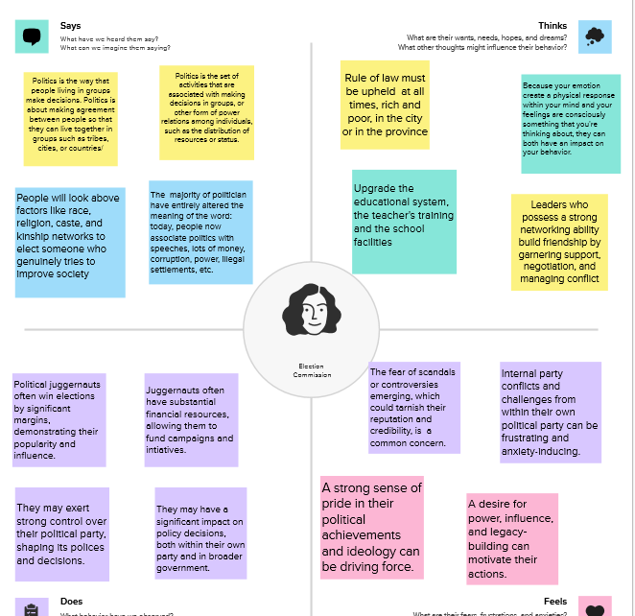 2.1 Empathy Map

2.2 Ideation & Brainstorming Map:

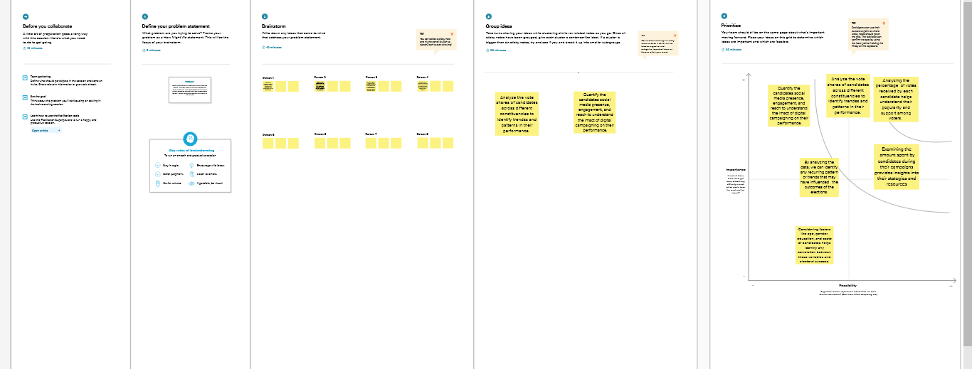

**3. RESULT:**

Dashboard

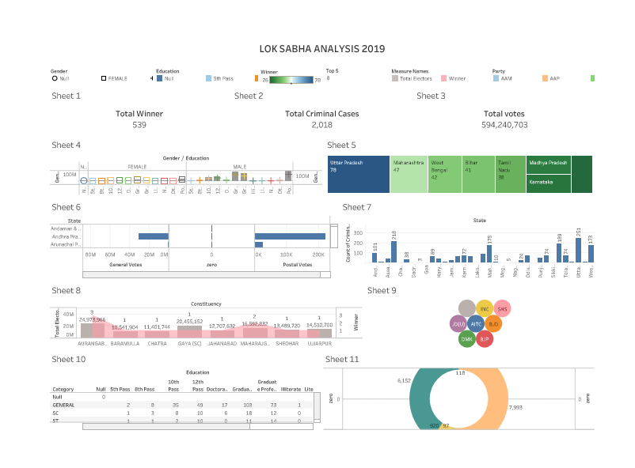

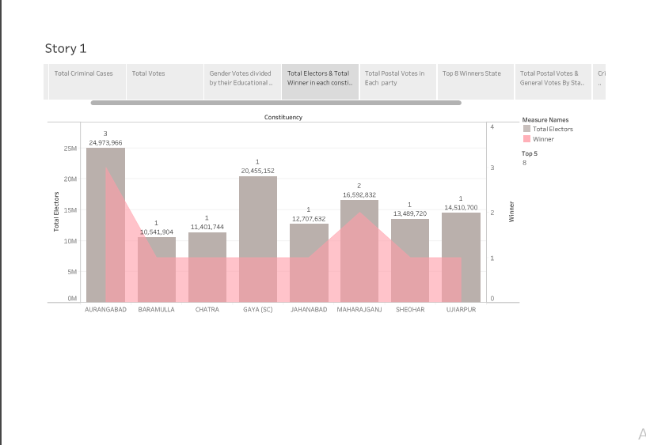 Story

1. **ADVANTAGES & DISADVANTAGES:**

The advantages and disadvantages of the project are given below:

**Advantages:**

* Data-Driven Insights: Quantitative analysis relies on data, enabling a systematic and objective evaluation of candidates’ performance, campaign strategies, and voter preferences.
* Accountability: It holds candidates accountable for their promises and actions by assessing their actual performance based on measurable criteria.
* Transparency: Quantitative analysis promotes transparency as it relies on publicly available data, making it easier for the public to access and understand the evaluation process.
* Identifying Trends: It helps identify trends and patterns in candidate performance, which can be useful for political parties and researchers to make informed decisions.
* Fairness: By focusing on measurable criteria, quantitative analysis can reduce bias and subjectivity in candidate evaluation.

**Disadvantages:**

* Limited Scope: Quantitative analysis may overlook qualitative aspects of a candidate’s performance, such as their charisma, communication skills, and ability to connect with constituents.
* Data Quality: The quality of data can vary, leading to potential inaccuracies in the analysis. Relying solely on data may not capture the full picture.
* Simplification: It may oversimplify complex political dynamics and issues, as quantitative analysis often deals with numbers and statistics, neglecting nuances.
* Lack of Context: Quantitative analysis might not consider the unique regional or socio-economic factors that can affect a candidate’s performance.
* Manipulation: There’s a risk that candidates or parties may attempt to manipulate or distort data to present a more favorable image.

In summary, quantitative analysis of candidates in the 2019 Lok Sabha elections provides valuable insights but should be complemented with qualitative assessments to get a more comprehensive understanding of their performance and impact.

1. **APPLICATIONS:**

A quantitative analysis of candidates in the 2019 Lok Sabha elections can have various applications, including:

1. **Predictive Modeling:** Quantitative data on candidates’ profiles, demographics, and electoral history can be used to build predictive models to forecast election outcomes and identify key factors that influence voters’ choices.
2. **Campaign Strategy:** Parties can use quantitative analysis to target their campaign efforts more effectively by understanding which constituencies or demographics are more likely to support their candidate.
3. **Voter Profiling:** By analyzing quantitative data, political parties can create voter profiles, helping them tailor their messaging and policies to resonate with specific segments of the electorate.
4. **Candidate Selection:** Political parties can use data-driven analysis to select the most viable candidates based on their past performance and the demographics of their constituencies.
5. **Issue Prioritization:** Quantitative analysis can identify the most pressing issues in each constituency, helping candidates focus their campaign promises and agendas.
6. **Resource Allocation:** Parties can allocate their resources more efficiently by identifying constituencies where their candidates have a better chance of winning.
7. **Post-Election Analysis:** After the elections, quantitative analysis can be used to assess the performance of candidates, parties, and the accuracy of pre-election predictions.
8. **Policy Formulation:** Elected candidates can use data analysis to understand the needs and concerns of their constituents, helping them formulate policies that address specific issues.
9. **Constituency Development:** Elected candidates can use data to prioritize and target development projects in their constituencies effectively.
10. **Academic Research:** Researches can use quantitative data from elections for various academic studies, including understanding voter behavior, political dynamics, and the impact of policies on election results.

Quantitative analysis of candidates in election plays a crucial role in modern political campaigns and governance, allowing for data-driven decision-making and a better understanding of the electorate.

1. **CONCULSION:**

As a student conducting a quantitative analysis of candidates in the 2019 Lok Sabha elections, I would draw several conclusions based on the data and research findings: The majority of candidates were affiliated with established political parties, highlighting the influence of party politics in Indian elections. Educational Background of many candidates had higher education qualifications, emphasizing the importance of education in Indian politics. Policy implications of conclusions could highlight the need for electoral reforms, such as gender quotas, to promote more democracy. Overall, the quantitative analysis of candidates in the 2019 Lok Sabha elections would provide valuable insights into the dynamics of Indian democracy and guide future research and policy decisions.

1. **FUTURE SCOPE:**

The future scope for a quantitative analysis of candidates in the 2019 Lok Sabha elections is broad and holds the potential for further research and policy development. Here are some areas of future research and implications:

* **Longitudinal Studies:** Extend the analysis to include data from subsequent elections to identify trends and changes in candidate profiles, such as gender representation and educational backgrounds.
* **Causative Analysis:** Investigate the causal factors that lead to particular candidate characteristics, for example, how party affiliations influence candidate selection.
* **Voter Behavior and Decision-Making:** Explore the intricacies of voter behavior and decision-making, including how candidate attributes impact voter choices and election outcomes.
* **Electoral Reforms:** Evaluate the effectiveness of electoral reforms in increasing gender representation and promoting diversity among candidates.
* **Campaign Finance Regulations:** Study the impact of campaign finance regulations on candidate viability and electoral success.
* **Regional Analysis:** Conduct region-specific studies to understand how candidate profiles vary across different states and regions in India.
* **Comparative Studies:** Compare the findings from the 2019 Lok Sabha elections with subsequent election cycles to identify evolving patterns and dynamics.
* **Impact on Governance:** Assess how the profiles of elected candidates influence governance, policymaking, and the overall functioning of the Lok Sabha.
* **Election Reform:**  Use your analysis to advocate for electoral reforms and better candidate selection processes by political parties.
* **Educational Initiatives:** Develop educational resources and tools for students and researchers to study the dynamics of Indian election**.**

This kind of analysis can have a significant impact on Indian politics and provides valuable insights for various stakeholders.

1. **APPENDIX:**

Tableau Profile Link:

[**https://public.tableau.com/app/profile/kashika.c.a**](https://public.tableau.com/app/profile/kashika.c.a)**.**